- ASSIGNMENT-2
NAME : SRI VIDYA NIIKETHITHAN R
ROLL NO : 717819L344
TEAM ID : PNT2022TMID12914

QUESTION:
Build a python code, Assume u get temperature and humidity values (generated with a random function to a variable) and write a condition to detect an alarm in case of high temperature continuously.
CODE:
import random
import time
while True:
temperature = random.randint(1,100)
humidity = random.randint(1,100)
print("Temperature: ", temperature)
print("Humidity: ", humidity)
if temperature >= 60 and (30 < humidity > 60):
print("Alarm ON!")
else:
print("Alarm OFF!"
time.sleep(2)
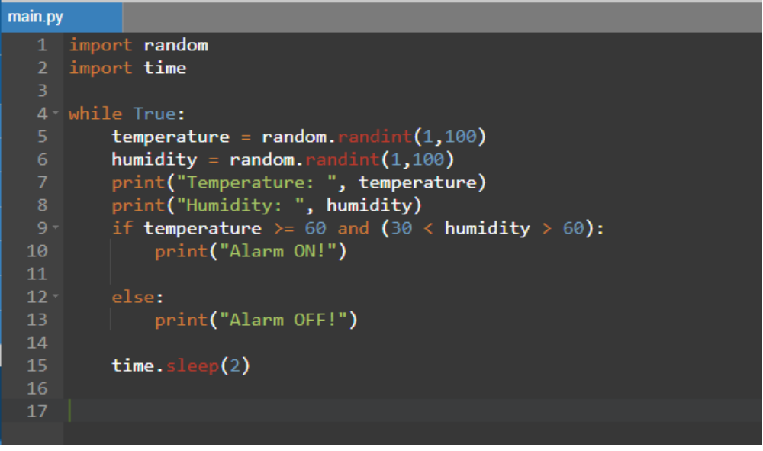
OUTPUT:
